Try the example: Arabidopsis in response to cold.

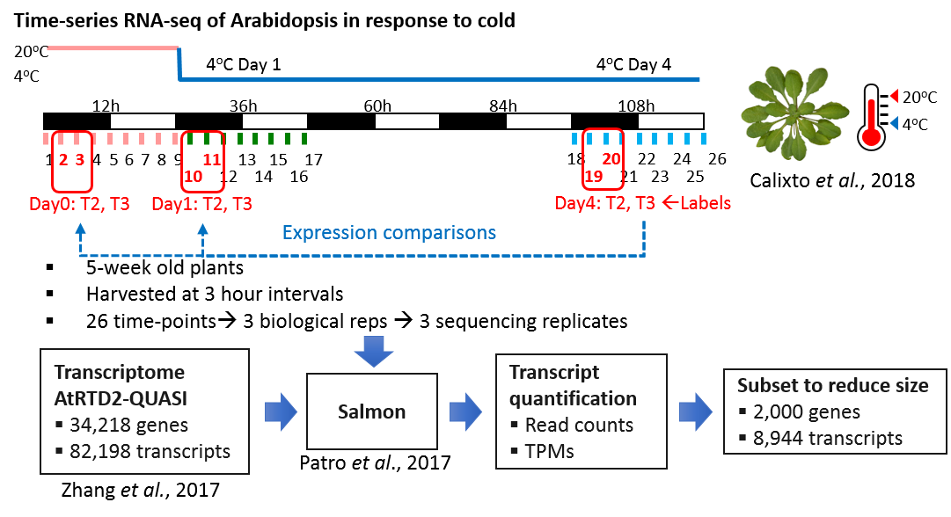

* The RNA-seq data had 6 factor groups (T2.Day0, T3.Day0, T2.Day1, T3.Day1, T2.Day4, T3.Day4) and each had 3 biological replicates and 3 sequencing replicates (18 samples in total).
* To compare the expression changes between conditions of experimental design, the contrast groups can be set as:
  + T2.Day1-T2.Day0
  + T2.Day4-T2.Day0
  + T3.Day4-T3.Day0
  + (T3.Day1+T2.Day1)/2-(T3.Day0+T2.Day0)/2
  + (T3.Day4+T2.Day4)/2-(T3.Day0+T2.Day0)/2
  + (T3.Day1-T2.Day1)-(T3.Day0-T2.Day0)
  + (T3.Day4-T2.Day4)-(T3.Day0-T2.Day0)